1. **Introductory concepts of DBMS**
2. [What are the disadvantages of File processing?](http://www.myreadingroom.co.in/notes-and-studymaterial/65-dbms/461-problems-with-file-system.html)

**Data redundancy and inconsistency**

Multiple file formats, duplication of information in different files

**Difficulty in accessing data**

Need to write a new program to carry out each new task

**Data isolation**

Multiple files and formats

**Integrity problems**

Integrity constraints (e.g., account balance > 0) become “buried” in

program code rather than being stated explicitly

Hard to add new constraints or change existing ones

**Atomicity of updates**

es may leave database in an inconsistent state with partial updates

carried out

Example: Transfer of funds from one account to another should either

complete or not happen at all

**Concurrent access by multiple users**

Concurrent access needed for performance

Uncontrolled concurrent accesses can lead to inconsistencies

Example: Two people reading a balance (say 100) and updating it by

withdrawing money (say 50 each) at the same time

**Security problems**

Hard to provide user access to some, but not all, data

**Advantages of Database Management System (DBMS)**

1. Improved data sharing

2. Improved data security

3. Better data integration

4. Minimized data inconsistency

5. Improved data access

6. Improved decision making

7. Increased end-user productivity

**Disadvantages of Database Management System (DBMS):**

1. Increased costs

2. Management complexity

3. Maintaining currency

4. Frequent upgrade/replacement cycles

**Levels of Abstraction**

**Physical level**: describes how a record (e.g., instructor) is stored.

**Logical level**: describes data stored in database, and the relationships among

the data.

type instructor = record

ID : string;

name : string;

dept_name : string;

salary : integer;

end;

**View level**: application programs hide details of data types. Views can also

hide information (such as an employee’s salary) for security purposes.

**View of Data**

An architecture for a database system

**Types of Data Base**

**1) Classification Based on the number of user**

Single user

Multiple work group DB

**2) Classification Based on location**

Centralized DB

Distributed DB

**3) Classification Based on how they use**

Operation DB

Transaction DB

**4) Degree to which Data are structured**

Unstructured data

Semi-structure Data

Structure Data

**5) DB System User**

Naive user

End User

System Analyst & Application Programmer

DBA

**List and explain the applications of DBMS.**

**Railway Reservation System**

**Library Management System**

**Banking**

**Credit card transactions**

**Universities and colleges**

Social Media Site

**Online Shopping**

**Finance**

**Manufacturing**

**Airline Reservation system**

Describe functions of DBA to handle DBMS.

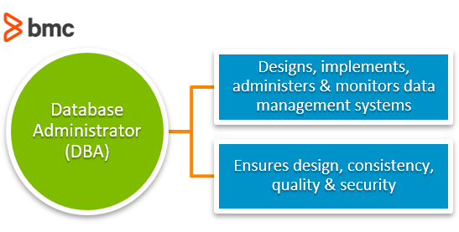

DBA stands for 'Database Administrator' their ate some functions of DBA that is-

1.Conceptual Architecture Schema.

2.Authorization and Integrity Schema.

3.Granting of User Access.

4.Backup and Recovery Mechanisms.

5.Monitering Performance.

6.Physical Database Design.

## Disadvantages of Relational Model in DBMS

The different disadvantages of Relational model are as follows:

1. Substantial hardware and system software overhead

2. Possibility of poor design and implementation

3. Potential “islands of information” problems

## The advantages of ER model in DBMS

1. Exceptional conceptual simplicity  
2. Visual representation  
3. Effective communication tool  
4. Integrated with the relational database model

## The disadvantages of ER Model in DBMS

1. Limited constraint representation  
2. Limited relationship representation  
3. No data manipulation language  
4. Loss of information content

[Explain different types of keys available in Relational Model.](http://www.myreadingroom.co.in/notes-and-studymaterial/65-dbms/476-types-of-keys-in-dbms.html)

**Types of Keys in DBMS**

In the [Relational Database Model](http://www.myreadingroom.co.in/notes-and-studymaterial/65-dbms/470-relational-database-model.html), keys are important because they are used to ensure that each row in a table is uniquely identifiable. They are also used to establish relationships among tables and to ensure the integrity of the data.

**Composite key:**

A key may be composed of more than one attribute. Such a multi attribute key is known as a composite key.

**Relational Database Keys:**

**Superkey:** An attribute (or a combination of attributes) that uniquely identifies each row in a table.  
  
**Candidate key:** A minimal (irreducible) superkey. A superkey that does not contain a subset of attributes that is itself a superkey.  
  
**Primary key:** A candidate key selected to uniquely identify all other attribute values in any given row. Cannot contain null entries.

**Secondary key:** An attribute (or combination of attributes) used strictly for data retrieval purposes.  
  
**Foreign key:** An attribute (or combination of attributes) in one table whose values must either match the primary key in another table or be null.

Explain Mapping

# **Mappings**

Process of transforming request and results between three level it's called mapping.

There are the two types of mappings:

1. Conceptual/Internal Mapping
2. External/Conceptual Mapping

### **1. Conceptual/Internal Mapping:**

* The conceptual/internal mapping defines the correspondence between the **conceptual view and the store database.**
* It relates conceptual schema with internal schema.
* It specifies how conceptual record and fields are represented at the internal level.
* There could be one mapping between conceptual and internal levels.

### **2. External/Conceptual Mapping:**

* The external/conceptual mapping defines the correspondence between a particular external view and conceptual view.
* It relates each external schema with conceptual schema.
* Example: fields can have different data types; fields and record name can be changed; several conceptual fields can be combined into a single external field.
* There could be several mapping between external and conceptual levels.

# **Data Independence**

There are two types of data independence:

## 1. Logical Data Independence

* The ability to change the conceptual schema without having to change the external schema.
* Logical data independence is used to separate the external level from the conceptual view.
* If we do any changes in the conceptual view of the data, then the user view of the data would not be affected.
* Logical data independence occurs at the user interface level.

## 2. Physical Data Independence

* The ability to change the change the internal schema without having to change the conceptual schema.
* If we do any changes in the storage size of the database system server, then the Conceptual structure of the database will not be affected.
* Physical data independence is used to separate conceptual levels from the internal levels.
* Physical data independence occurs at the logical interface level.

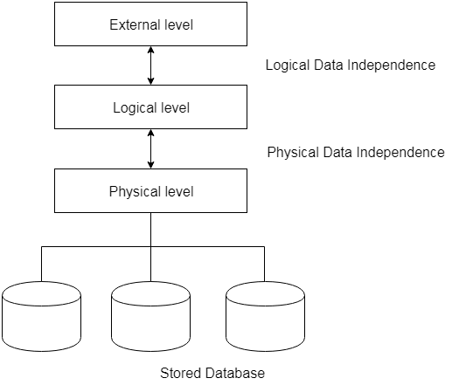

# **DBMS Architecture**

* The DBMS design depends upon its architecture.
* The basic client/server architecture is used to deal with a large number of PCs, web servers, database servers and other components that are connected with networks.
* The client/server architecture consists of many PCs and a workstation which are connected via the network.

Types of DBMS Architecture

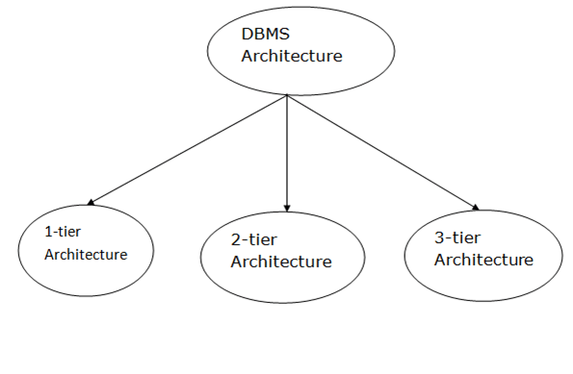

### **1-Tier Architecture**

* In this architecture, the database is directly available to the user.
* It means the user can directly sit on the DBMS and uses it.
* Any changes done here will directly be done on the database itself. It doesn't provide a handy tool for end users.
* The 1-Tier architecture is used for development of the local application, where programmers can directly communicate with the database for the quick response.

### **2-Tier Architecture**

* The 2-Tier architecture is same as basic client-server.
* In the two-tier architecture, applications on the client end can directly communicate with the database at the server side.
* The user interfaces and application programs are run on the client-side.
* The server side is responsible to provide the functionalities like: query processing and transaction management.
* To communicate with the DBMS, client-side application establishes a connection with the server side.

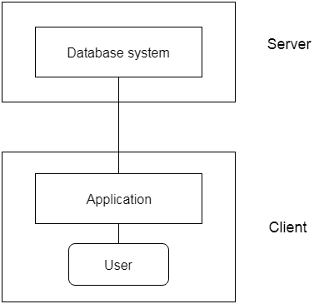

**Fig: 2-tier Architecture**

### **3-Tier Architecture**

* The 3-Tier architecture contains another layer between the client and server. In this architecture, client can't directly communicate with the server.
* End user has no idea about the existence of the database beyond the application server.
* The database also has no idea about any other user beyond the application.
* The 3-Tier architecture is used in case of large web application.

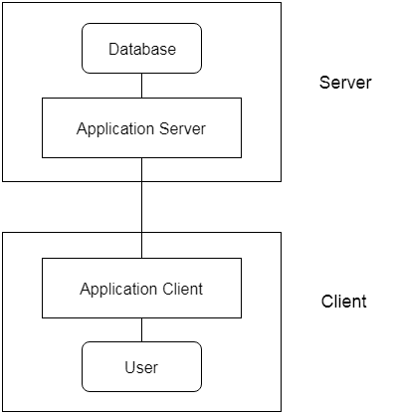

**Fig: 3-tier Architecture**

Define the terms: Super key, Candidate key, Primary key, Foreign

key, Alternate key and Unique key.

* It is used to uniquely identify any record or row of data from the table. It is also used to establish and identify relationships between tables.

1. Primary Key

 A **primary key** is a minimal set of attributes (columns) in a table that uniquely identifies tuples (rows) in that table.

Primary Key rules

* A primary key may have one or more attributes.
* There is only one primary key in the relation (table).
* A primary key attribute value cannot be NULL.

1. Super Key

* A **Super key** is a set of attributes or more in a table that uniquely identifies each records in that table.

1. Candidate Key

* A candidate key is a subset of a super key.
* A candidate key is a single attribute or the least combination of attributes that uniquely identifies each record in the table.
* Every candidate key is a super key but every super key is not a candidate key.

1. Foreign Key

* A Foreign Key is a database key that is used to link two tables together.
* A foreign key is a column or set of columns in one table whose values must have matching values in the primary key of another (or the same) table.

1. Alternate Key

* Alternate keys are those candidate keys which are not the Primary key. There can be only one Primary key for a table.
* Therefore all the remaining Candidate keys are known as Alternate or Secondary keys.

What is E-R diagram?

* E-R diagram: (Entity-Relationship diagram)
* It is graphical (pictorial) representation of database.
* It uses different types of symbols to represent different objects of database.

Enity

* An entity is a person, a place or an object.
* An entity is represented by a rectangle which contains the name of an entity.

Enity Set

* It is a set (group) of entities of same type.

**Library Management System ER Diagram**

Entities and their Attributes –

Book Entity : It has authno, isbn number, title, edition, category, price. ISBN is the Primary Key for Book Entity.

Reader Entity : It has UserId, Email, address, phone no, name. Name is composite attribute of firstname and lastname. Phone no is multi valued attribute. UserId is the Primary Key for Readers entity.

Publisher Entity : It has PublisherId, Year of publication, name. PublisherID is the Primary Key.

Authentication System Entity : It has LoginId and password with LoginID as Primary Key.

Reports Entity : It has UserId, Reg_no, Book_no, Issue/Return date. Reg_no is the Primary Key of reports entity.

Staff Entity : It has name and staff_id with staff_id as Primary Key.

Reserve/Return Relationship Set : It has three attributes: Reserve date, Due date, Return date.

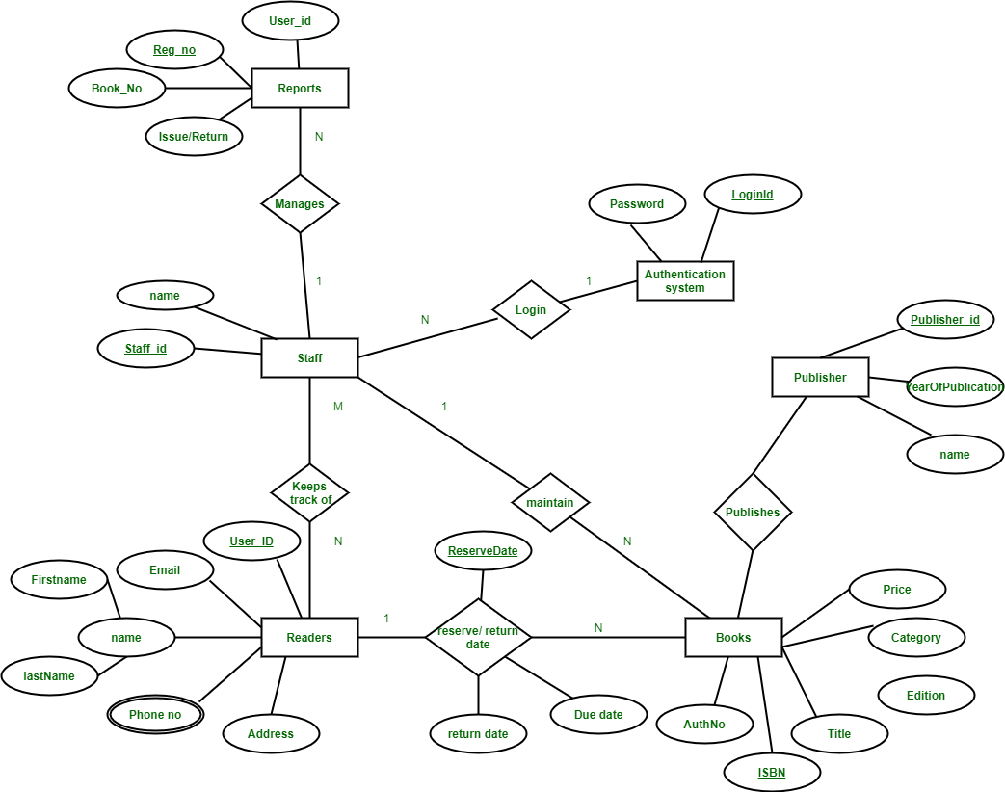

Hospital Management System ER Diagram

